Wallet System
# Source: Chatgpt (GPT-5-Mini) at [1/21/2026]
A wallet system is a digital platform or service that allows users to store, send, receive, and manage money electronically — often through mobile apps, web portals, or cards. It acts like a virtual bank account, but without necessarily being tied to a traditional bank.

🧠 Simple Definition
# Source: Chatgpt (GPT-5-Mini) at [1/21/2026]
A wallet system is a software-based financial tool that holds digital money (e.g., e-money, fiat, or even crypto) and enables digital transactions such as payments, transfers, and purchases.

🔍 Key Features of a Wallet System
# Source: Chatgpt (GPT-5-Mini) at [1/21/2026]
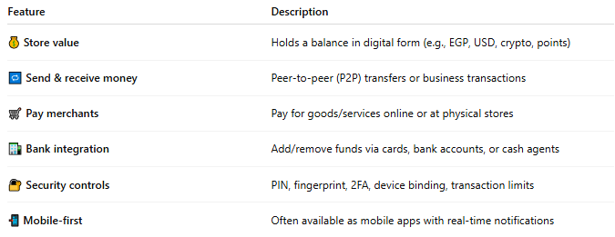

Feature | Description
💰 Store value | Holds a balance in digital form (e.g., EGP, USD, crypto, points)
🔁 Send & receive money | Peer-to-peer (P2P) transfers or business transactions
🛒 Pay merchants | Pay for goods/services online or at physical stores
🏦 Bank integration | Add/remove funds via cards, bank accounts, or cash agents
🔐 Security controls | PIN, fingerprint, 2FA, device binding, transaction limits
📲 Mobile-first | Often available as mobile apps with real-time notifications

📦 Types of Wallet Systems
# Source: Chatgpt (GPT-5-Mini) at [1/21/2026]
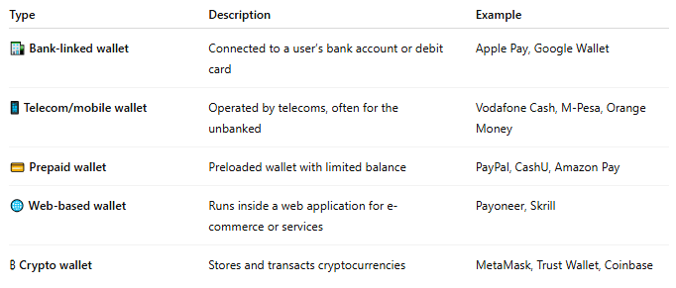
Type | Description | Example
🏦 Bank-linked wallet | Connected to a user’s bank account or debit card | Apple Pay, Google Wallet
📱 Telecom/mobile wallet | Operated by telecoms, often for the unbanked | Vodafone Cash, M-Pesa, Orange Money
💳 Prepaid wallet | Preloaded wallet with limited balance | PayPal, CashU, Amazon Pay
🌐 Web-based wallet | Runs inside a web application for e-commerce or services | Payoneer, Skrill
₿ Crypto wallet | Stores and transacts cryptocurrencies | MetaMask, Trust Wallet, Coinbase

🎯 What You Can Do with a Wallet System
# Source: Chatgpt (GPT-5-Mini) at [1/21/2026]
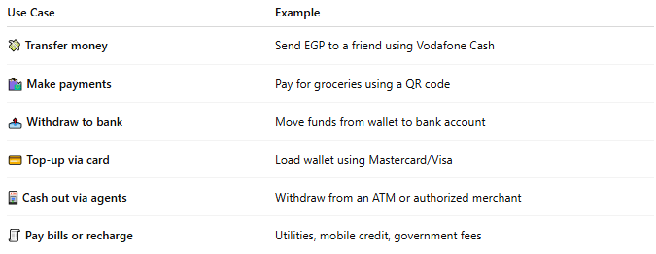

Use Case | Example
💸 Transfer money | Send EGP to a friend using Vodafone Cash
🛍️ Make payments | Pay for groceries using a QR code
📤 Withdraw to bank | Move funds from wallet to bank account
💳 Top-up via card | Load wallet using Mastercard/Visa
🏧 Cash out via agents | Withdraw from an ATM or authorized merchant
🧾 Pay bills or recharge | Utilities, mobile credit, government fees

🔐 Security & Compliance
# Source: Chatgpt (GPT-5-Mini) at [1/21/2026]
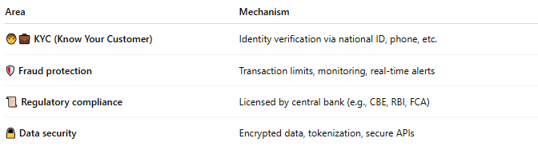

Area | Mechanism
🧑‍💼 KYC (Know Your Customer) | Identity verification via national ID, phone, etc.
🛡️ Fraud protection | Transaction limits, monitoring, real-time alerts
📜 Regulatory compliance | Licensed by central bank (e.g., CBE, RBI, FCA)
🔒 Data security | Encrypted data, tokenization, secure APIs

🌍 Popular Wallet Systems by Region
# Source: Chatgpt (GPT-5-Mini) at [1/21/2026]


Region | Popular Wallets
Egypt | Vodafone Cash, Orange Money, Meeza Wallet
Africa | M-Pesa, Airtel Money, MTN Mobile Money
US/Europe | PayPal, Apple Pay, Google Pay
Asia | Alipay, WeChat Pay, Paytm

✅ Benefits of Wallet Systems
# Source: Chatgpt (GPT-5-Mini) at [1/21/2026]
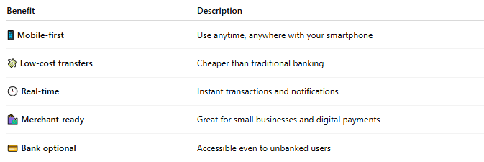

Benefit | Description
📱 Mobile-first | Use anytime, anywhere with your smartphone
💸 Low-cost transfers | Cheaper than traditional banking
🕒 Real-time | Instant transactions and notifications
🛍️ Merchant-ready | Great for small businesses and digital payments
💳 Bank optional | Accessible even to unbanked users

⚠️ Challenges
# Source: Chatgpt (GPT-5-Mini) at [1/21/2026]
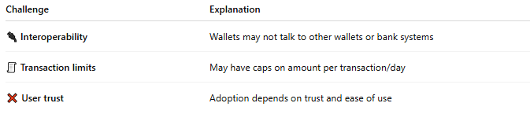

Challenge | Explanation
🔌 Interoperability | Wallets may not talk to other wallets or bank systems
🧾 Transaction limits | May have caps on amount per transaction/day
❌ User trust | Adoption depends on trust and ease of use

🧠 Summary
# Source: Chatgpt (GPT-5-Mini) at [1/21/2026]
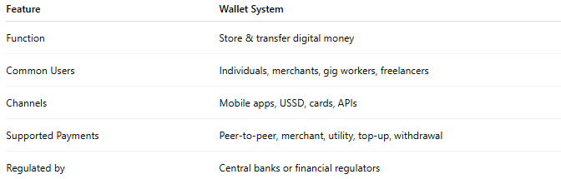

Feature | Wallet System
Function | Store & transfer digital money
Common Users | Individuals, merchants, gig workers, freelancers
Channels | Mobile apps, USSD, cards, APIs
Supported Payments | Peer-to-peer, merchant, utility, top-up, withdrawal
Regulated by | Central banks or financial regulators

